TABLEAU_DE_EU_US_In Class_Session3
tableau_de_ds2_s3
Training Clarusway
Pear Deck - June 22, 2022 at 11:52PM

Part 1 - Summary
Use this space to summarize your thoughts on the lesson

Part 2 - Responses
Slide 1
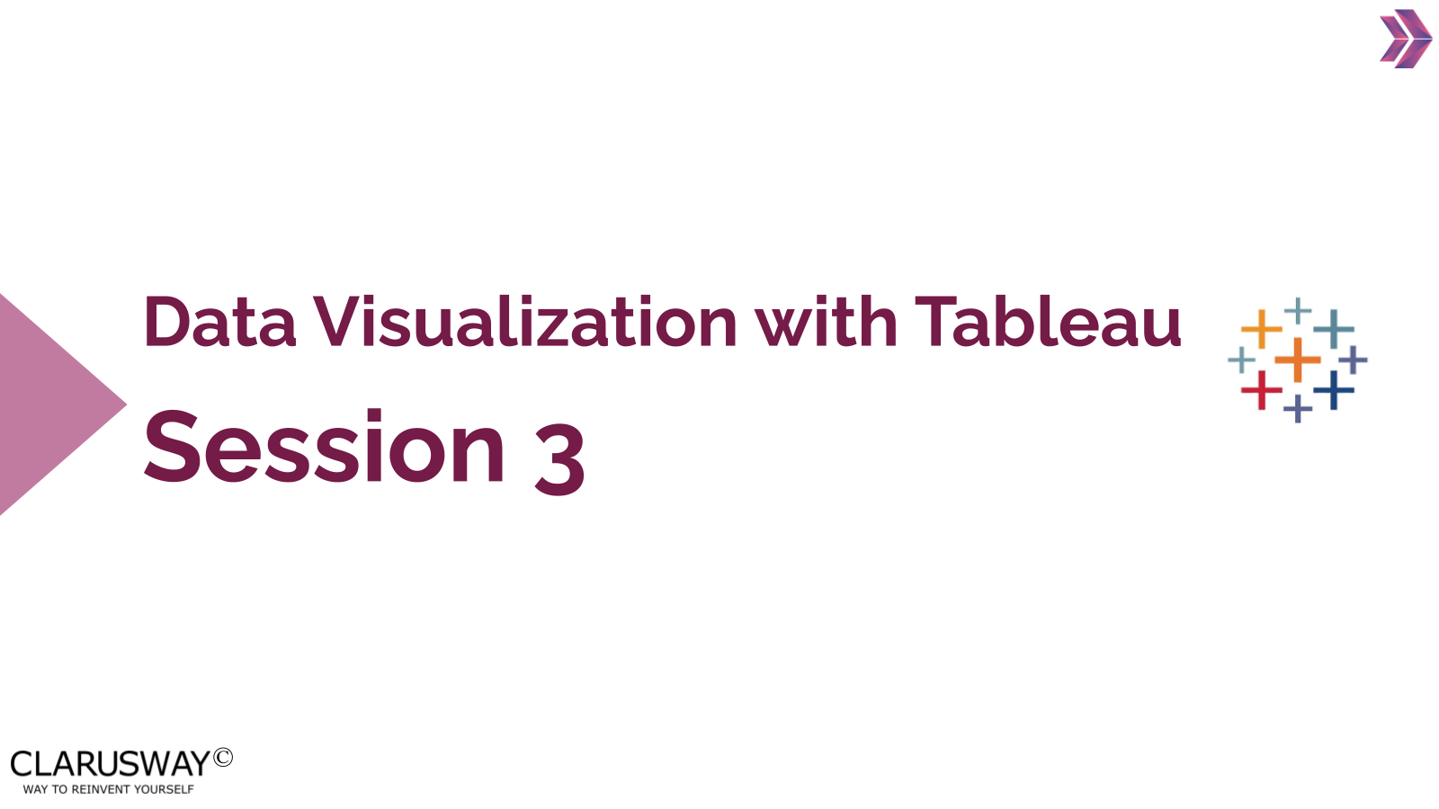

Use this space to take notes:

Slide 2 | Your Response
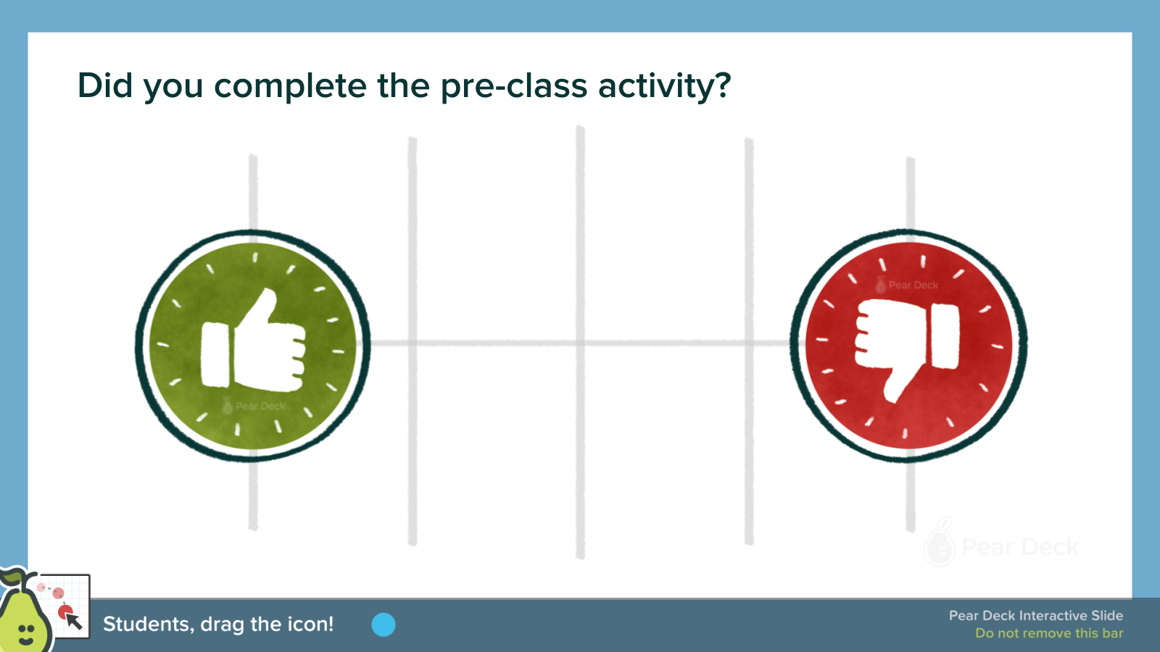 | 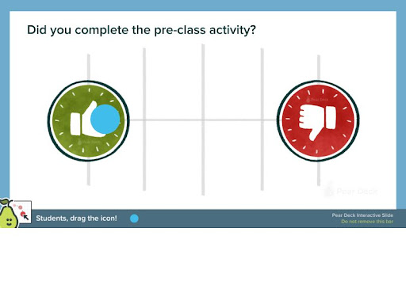
Use this space to take notes:

Slide 3
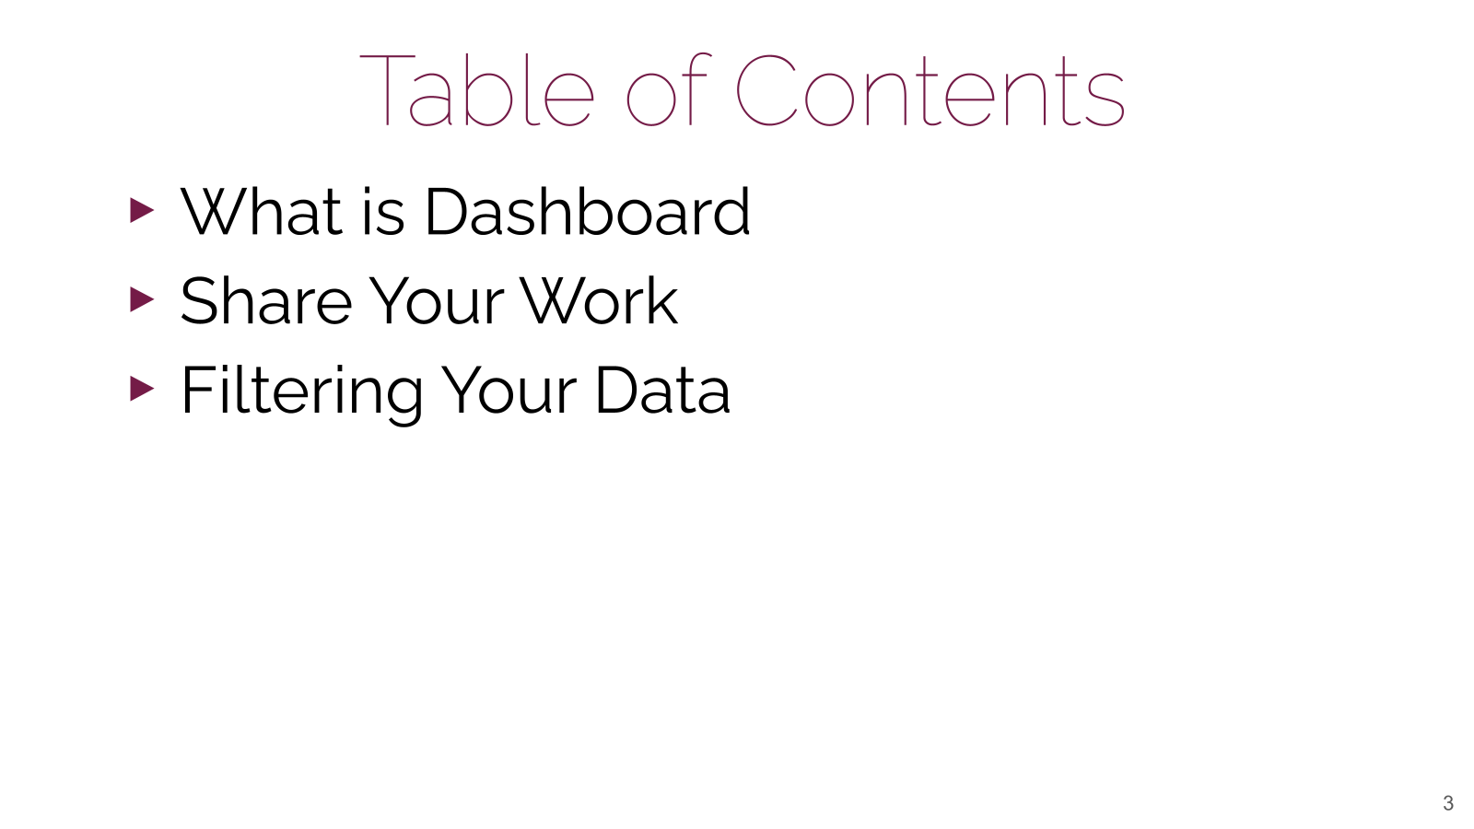

Use this space to take notes:

Slide 4
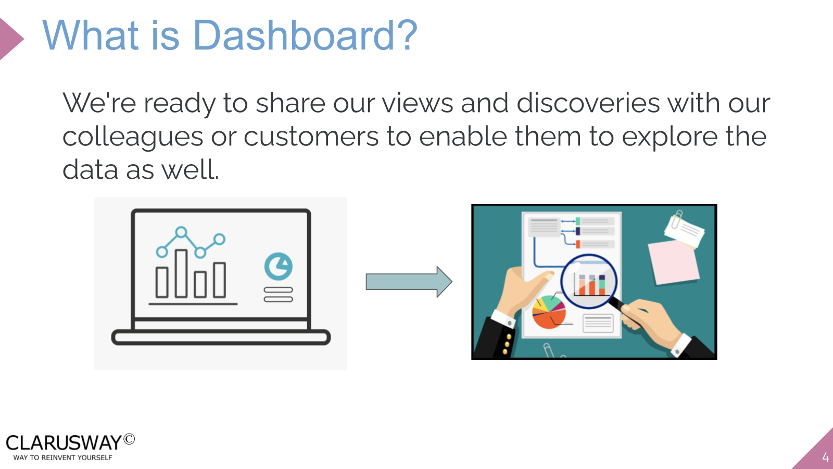

Use this space to take notes:

Slide 5
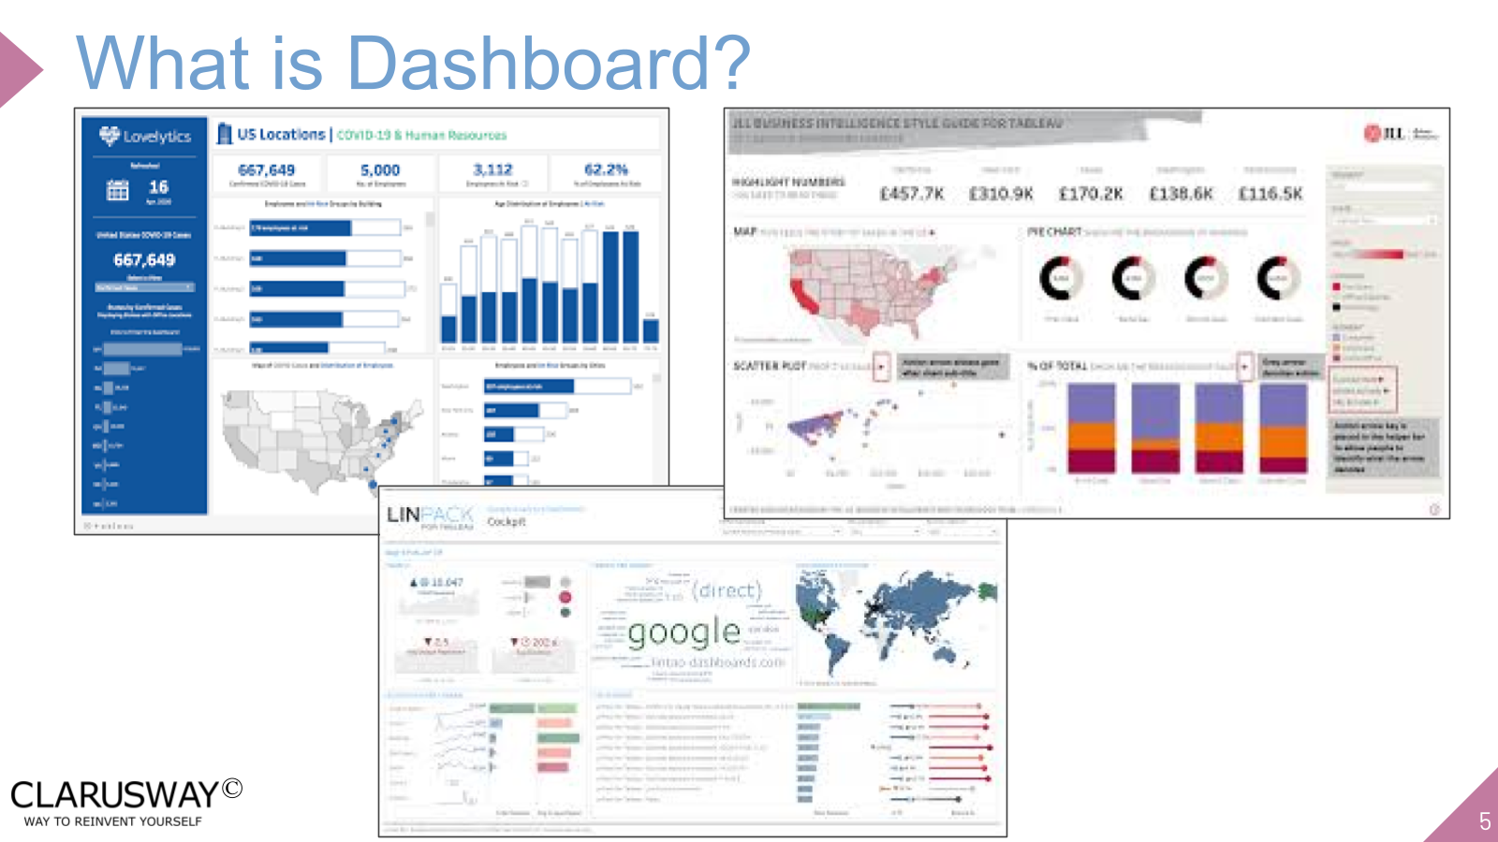

Use this space to take notes:

Slide 6
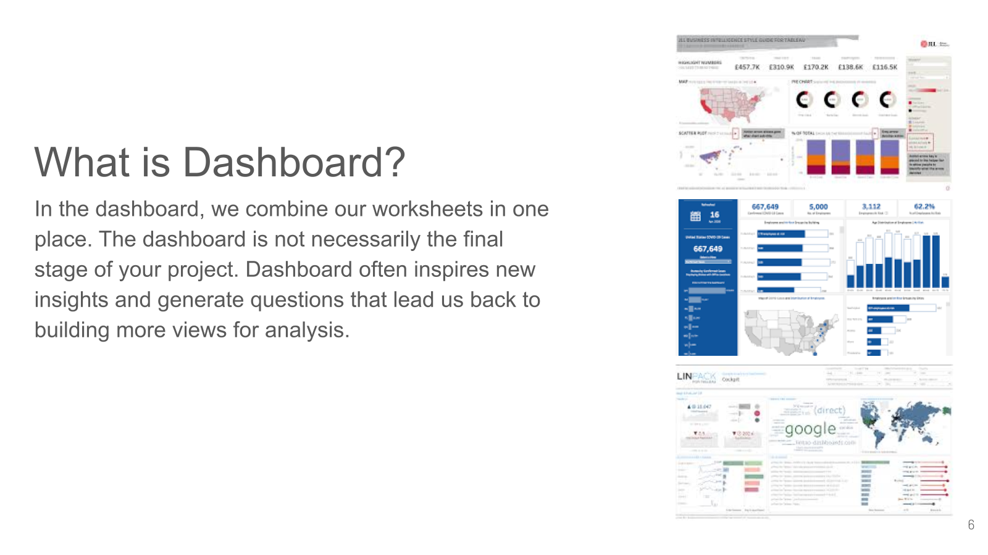

Use this space to take notes:

Slide 7
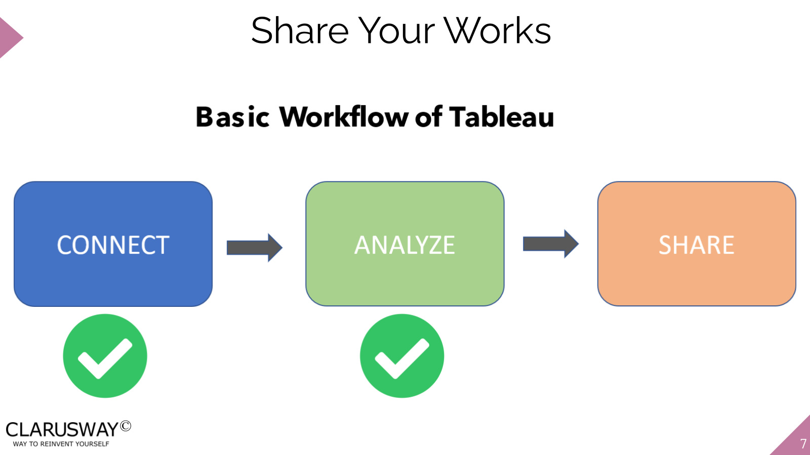

Use this space to take notes:

Slide 8
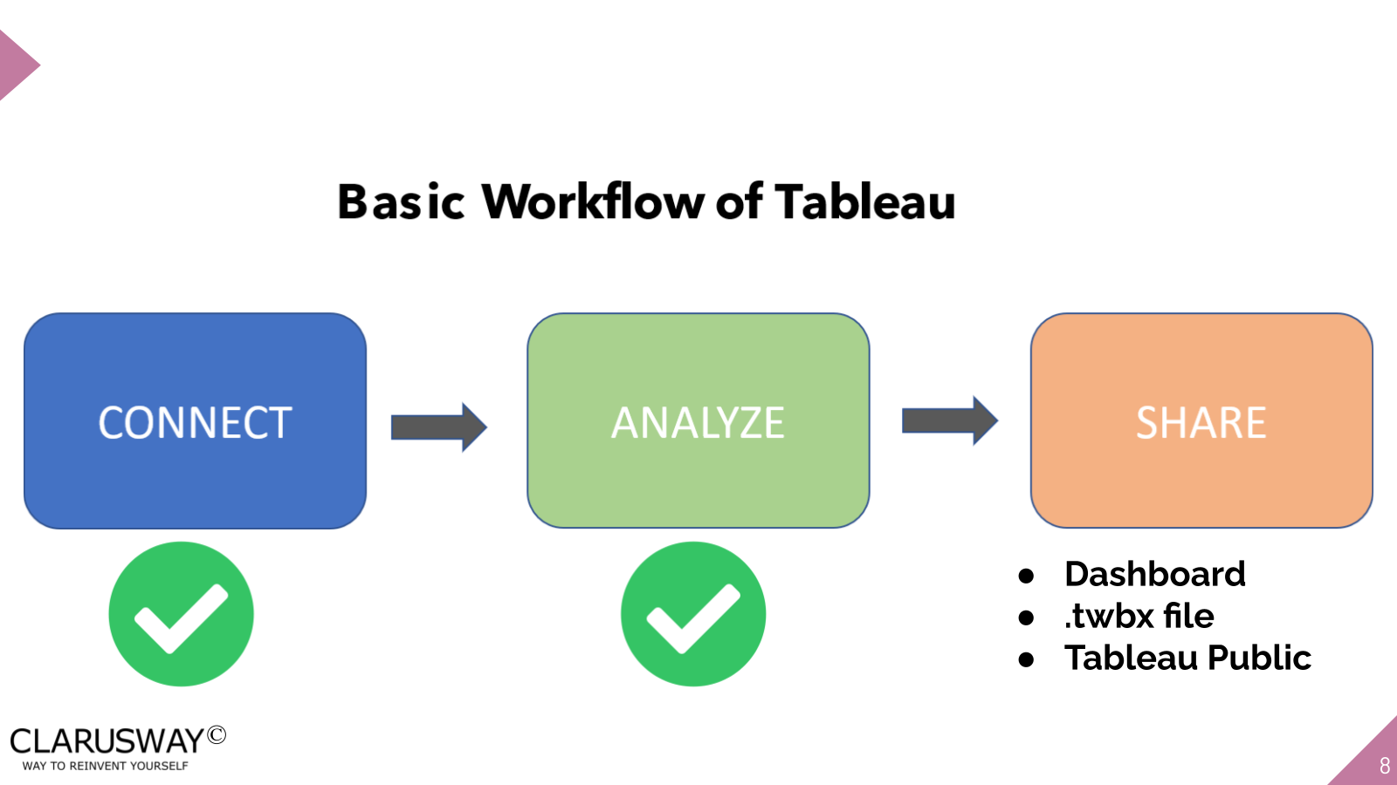

Use this space to take notes:

Slide 9
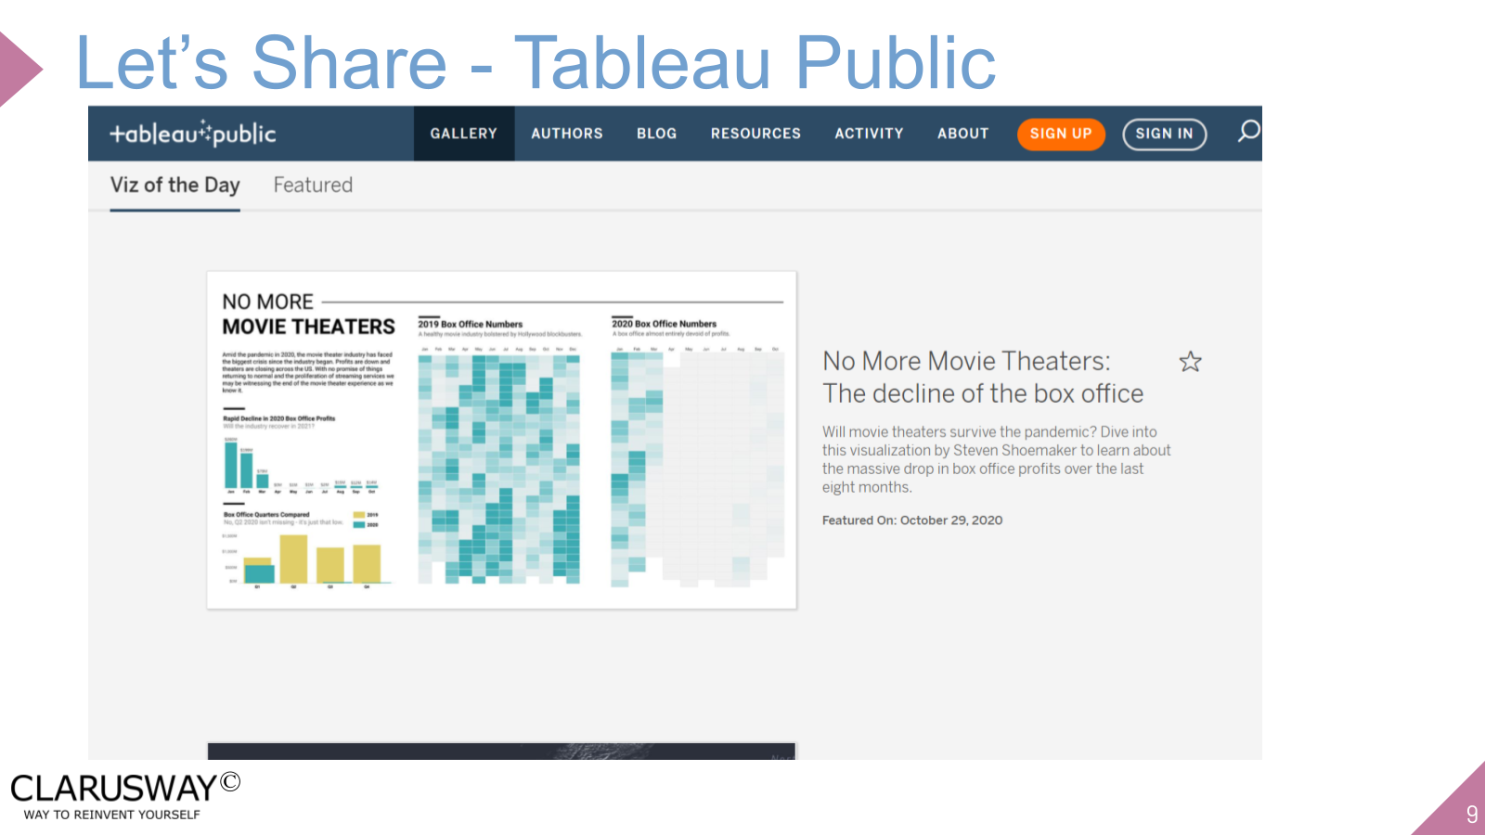

Use this space to take notes:

Slide 10
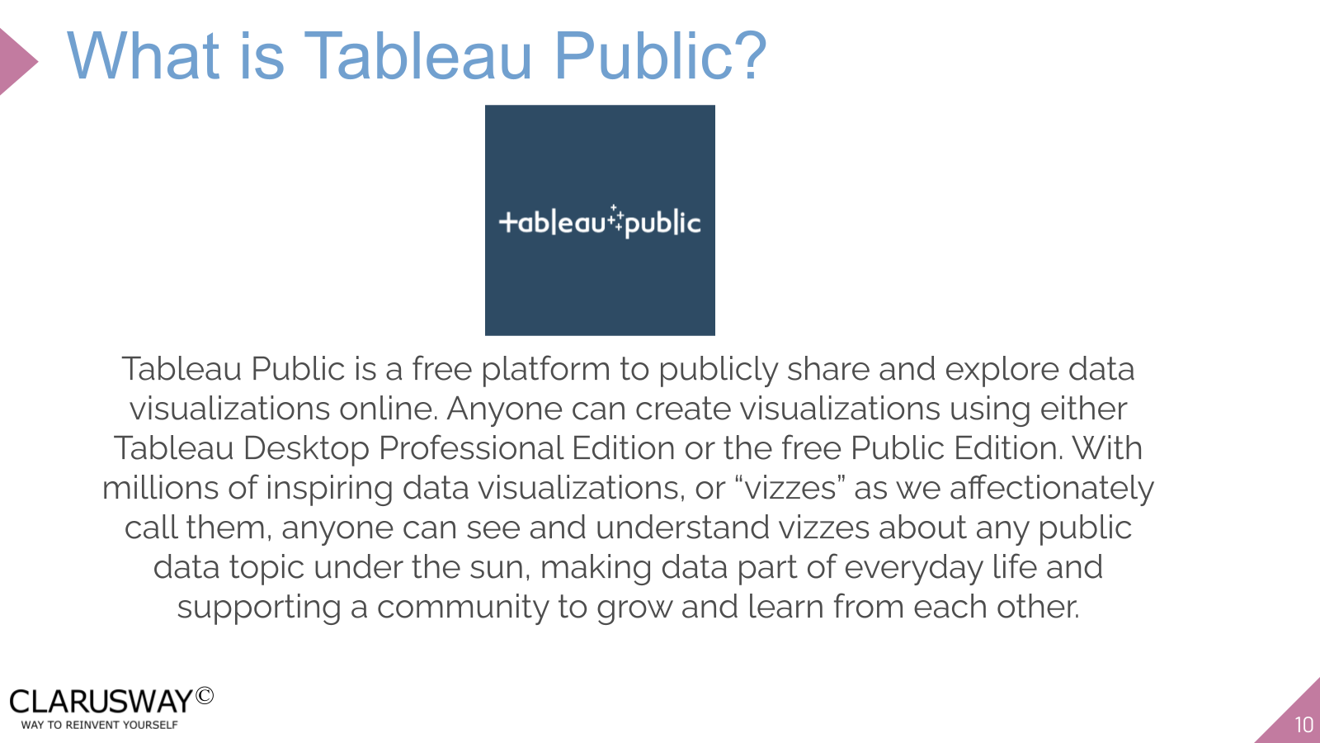

Use this space to take notes:

Slide 11
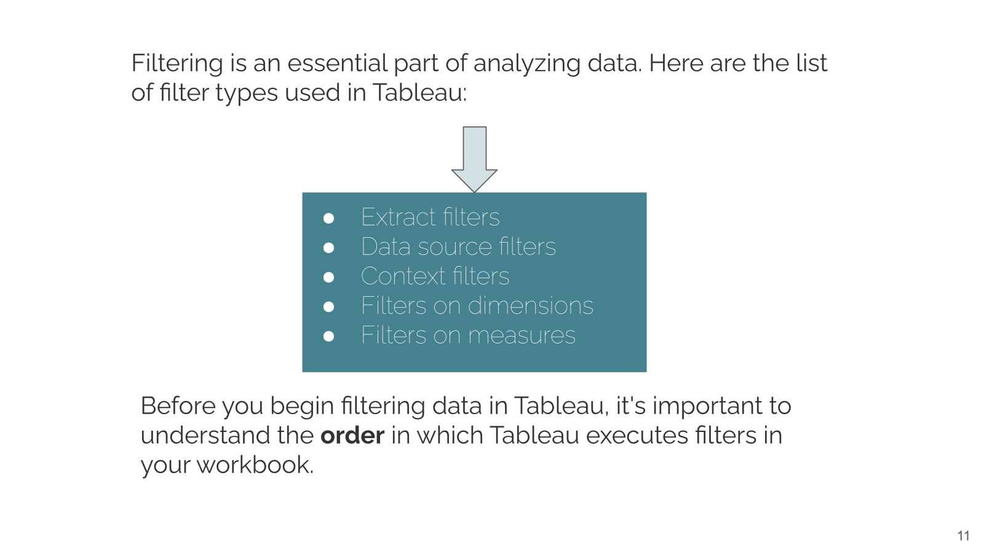

Use this space to take notes:

Slide 12
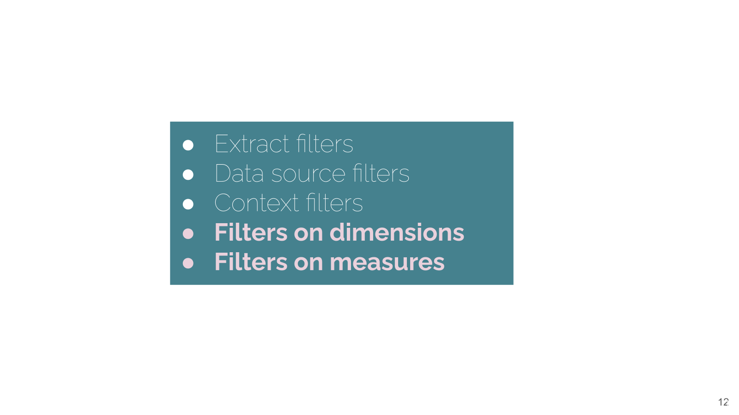

Use this space to take notes:

Slide 13
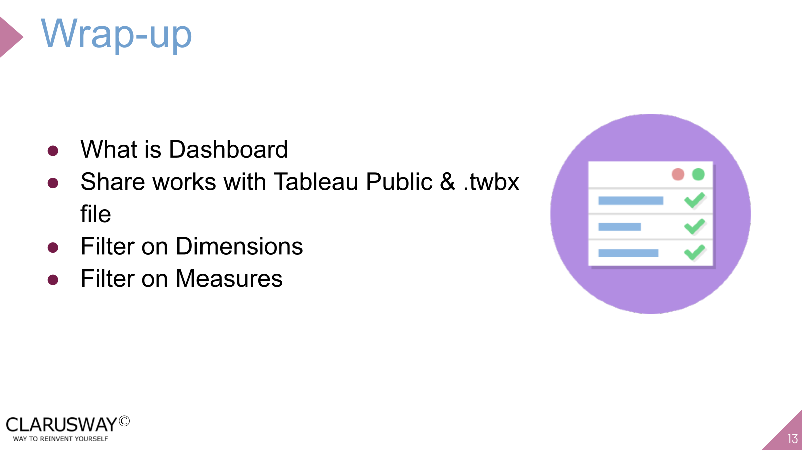

Use this space to take notes:

Slide 14 | Your Response
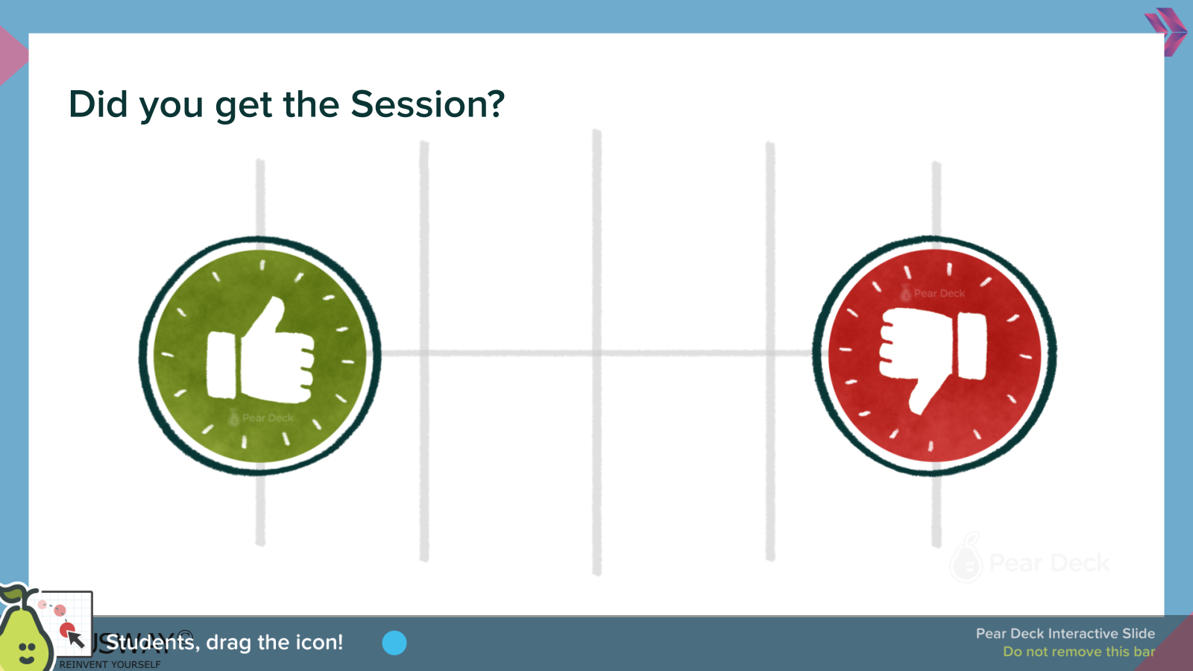
Use this space to take notes:

Slide 15
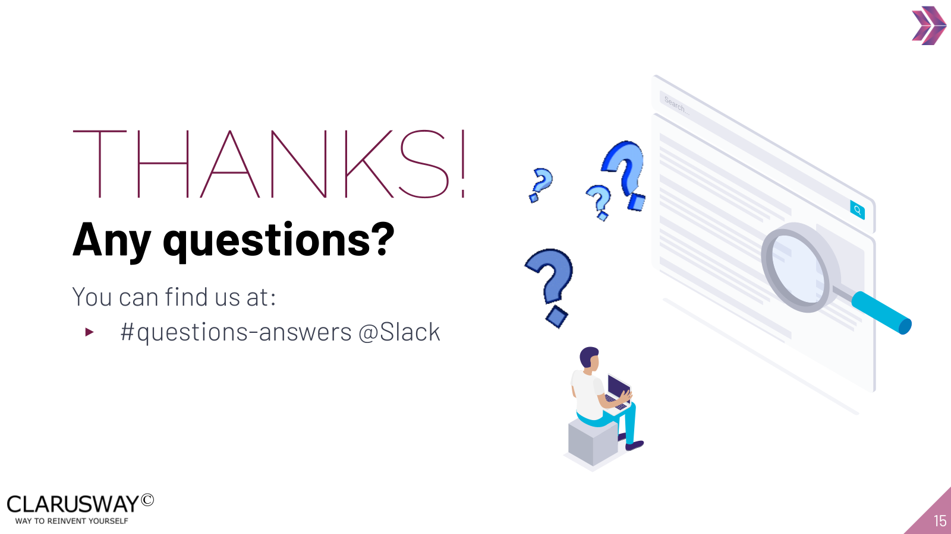

Use this space to take notes:

